Cube Test SOP

This process is to be initiated once per month to verify minimum dimensional quality of our product from the milling room processes. Please check appropriate boards for actual times or contact your supervisor for more detailed information.

Step 1

Utilizing the nesting software for the mill to be tested, nest the test cube .stl file in a puck with any other crowns waiting to be milled. Shade is not a concern of this test. Only an incorrect scaling factor could impact this test and that should be verified between the software and the puck being used. If you do not know how to do this, ask your team lead or other senior operator.

Step 2

Mill the test cube and follow the rest of the milling process for crowns as usual.

Step 3

Green state should be MINIMAL in that the cube should only have the two sprues removed. **No other surface processing of the cube should take place to prevent dimensional changes** at the end of the line.

Step 4

Sinter test cube per crown process as usual.

Step 5

Measure test cube in X, Y, and Z axis and enter values into spreadsheet provided.

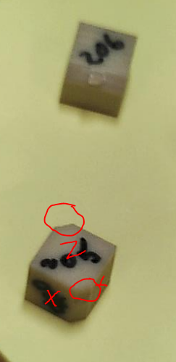

Please be aware that X and Y will change based on nesting. The exact position of these is irrelevant anyway. Only their dimensions will directly impact our product. The Z, on the other hand, is specifically located by finding the surface perpendicular to the sprue flats. When documenting the caliper measurements, X and Y may be swapped with no ill affect. Z should always be Z on every cube measured. If you do not understand how to find proper Z on the cube, stop and contact your team lead.

All axis measurements should be taken a minimum of five times. The mean of those five measurements should be entered as the “actual” axis measurement. If you do not understand how to find the mean of the caliper measurements on the cube, stop and contact your team lead.

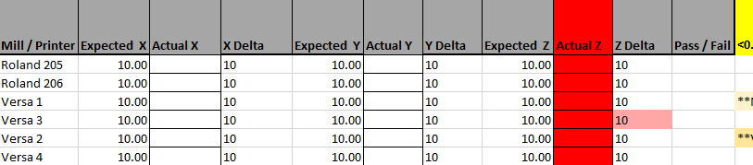

Step 6

**Anything above 10.2 mm or below 9.8 mm is failing and show by a red cell.**

Passing values will show up white. If a mill has a failing value, remeasure the cube, recalculate the means, and re-enter the values in the spreadsheet. **If it is still failing, put the mill in question down** and contact your team lead**. No product may run on a machine that fails this test** unless otherwise directed by management.